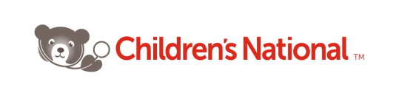
Children’s National Medical Center
Department of Transport Medicine
PALS Payment Instructions

**Please note: Staff must complete payment information prior to course registration**

Payment methods for Children’s National Medical Center PALS/PEARS courses:

IF YOU ARE A CHILDREN’S NATIONAL RN, DO NOT FOLLOW THESE STEPS. FOLLOW THIS LINK TO SUBMIT YOUR INFORMATION FOR A PROMO CODE. https://cnmc.proteanhub.com/public/show_form.php?form_id=69568

ALL NON-NURSING STAFF, FOLLOW THESE INSTRUCTIONS:

OPTION 1 – SELF-PAY:
Self-pay with a credit card on line or contact the PALS Administrator, Valerie Clarke, to pay by check or cash. Valerie Clarke, vclarke@childrensnational.org, 202-476-3199

OPTION 2 – Departmental Sponsorship:
Instructions for the PALS Registration Process for Departmental Sponsorship:
- CNMC Employee completes PALS Payment From.
- Employee submits form to their department for management approval.
- Send the PALS Payment Form to Valerie Clarke at vclarke@cnmc.org
- The PALS Program will add the employees CNMC email address to an approved list and a registration code will be sent to the employee by the PALS Program.
  - The employee’s CNMC email address will need to be on the approved list in order to use the code.
  - CNMC Employee’s must use their CNMC email address.
- The employee will receive an email with a registration code. This code must be entered into the “promo code” field at the time of registration. If the employee does not use the promo code during registration they will be required to enter credit card payment information. The email address and promo code must be entered exactly the way that they are sent to the employee.
- Cancellation and rescheduling requests must be sent to PALSProgram@childrensnational.org

